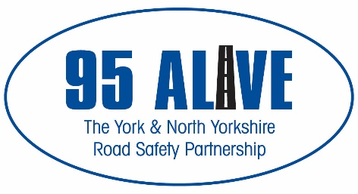

Office Use Only

Office use only
Speed Concern Form

Please Complete All Fields – Only ONE form is required to launch a review of a location

Name: (Dr / Mr / Mrs / Ms / Miss / Other)

Address: Postcode:

Tel: | Email:

Location of concern (road name):

At/ near to (house number / junction with):

Are there any days or times you feel are worse:
MON | TUE | WED | THUR | FRI | SAT | SUN | ALL DAYS
Times of day (please specify):

Types of vehicle: Car | Motorcycle | Van | Lorry | Bus | All Vehicles

Driven by: Local Residents / General Traffic / Commuters from / Employees of (delete as appropriate)
1. 2. 3.

Additional Information:

I would be willing to participate in any Community Action initiatives regarding the issue I have raised: YES / NO | Signature:

This form should be returned to –
North Yorkshire Police Traffic Bureau, PO Box 809, York, YO31 6DG
Email: speedconcerns@northyorkshire.pnn.police.uk Tel: 01904 618968
Facebook: www.facebook.com/NYPTrafficBureau
Please see reverse for general information that may help us, help you with your concern.

Information

The purpose of this form is to allow you to submit a concern about speed in your local community to the 95 Alive Partnership for review through the Speed Management Protocol. Only one form is required to start a review into a location of concern. We treat all concerns equally, in order of receipt, and no priority will be given based on the amount of forms submitted.

The aim of the 95 Alive Partnership is to reduce casualties on our roads and improve the safety and quality of life, both for people who live in the area and for those who travel through it. We review every concern we receive. On occasion, your concern will need to be handled by other partners within 95 Alive Partnership. Please take the time to read the following examples and who addresses them:

- Speed limit reductions and road signage: For the reduction of a speed limit or the installation of new/ more road signs, you will need to contact your local authority, as they manage and monitor these. City of York Council can be contacted via ycc@york.gov.uk or tel: 01904 551550. North Yorkshire County Council can be contacted via road.safety@northyorks.gov.uk

- Narrow pavements or lack of footpaths: If you feel unsafe from traffic whilst walking on a pavement because you feel it is too narrow, or live in an area where you regularly have to walk in the road due to the lack of a footpath, then you need to contact the Highways Agency at your local authority. They monitor and review locations and make the final decision on any form of engineering work.

- Concerns with a specific vehicle/ company vehicles: If you have concerns over a small number of vehicles, and have the details of them, whether it is one vehicle’s registration plate or you have concerns with a particular company’s vehicle, then this concern is not suitable to go through this process. Please contact ‘101’ who will be able to assist you. You also need to do this if you have concerns over how cyclists use the roads.

- Have you witnessed anti-social use of vehicles/ captured it on camera:
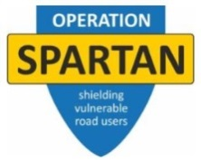
If you have witnessed or captured instances of anti-social use of vehicles or poor/ dangerous driving on a dashboard camera or other form of camera, then North Yorkshire Police have launched ‘Operation Spartan’ which aims to improve the attitudes of all who use our roads and increase the level of safety for all. Information on how to register and send these instances can be found here: https://northyorkshire.police.uk/what-we-do/road-policing/operation-spartan/ or by emailing: OpSpartan@northyorkshire.pnn.police.uk

This form should be returned to –
North Yorkshire Police Traffic Bureau, PO Box 809, York, YO31 6DG
Email: speedconcerns@northyorkshire.pnn.police.uk Tel: 01904 618968
Facebook: www.facebook.com/NYPTrafficBureau

