
Richmondshire Area Partnership Fund 2019-2020

Guidance & Criteria for Applicants

The Purpose of the Scheme

The Richmondshire Area Partnership Funding Scheme has been established to make available funding to each of the Area Partnerships to help with the delivery of groups within Richmondshire who wish to start new or continue existing projects which bring benefits to the community.

A total of £50,000 has been set aside for this financial year, with each Area Partnership allocated £10,000 each. Applications received will be categorised into one of the five “Area Partnership” areas, based on the project location. These areas are defined as Central Richmondshire, The Garrison, Lower Wensleydale, North Richmondshire and Upper Dales and have been split in line with the image below:

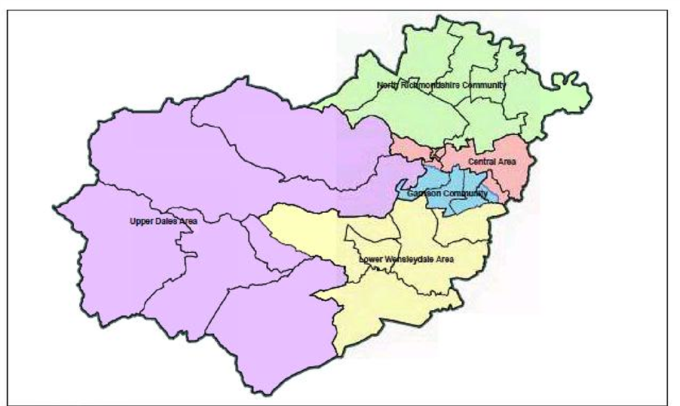

Eligibility

- It is a maximum of £1,000 per application.
- Capital or revenue projects that have been identified in either in a Parish Plan, local community action plan an Area Partnership Action Plan or through community consultation (e.g. equipment, building enhancements, sports clubs and community activities)
- Available to Parish and Town Councils, Parish Meetings, voluntary organisations and community groups with a constitution or set of rules
- Applicants must be able to clearly demonstrate a demand or need for the project from the local community.
- The maximum percentage of the total project costs which can be applied for from this scheme is, is 75%
- The project must be completed before the end of the financial year end in which the application was submitted (31 March 2020)
- The organisation must be solvent and not have more than 12 months running costs in unrestricted reserves
- Match funding must not be from an alternative District Council funding source.
- Grants awarded are only paid following the production of relevant invoices/receipts
- RDC reserves the right to withdraw the grant where spend is not in line with the offer made and accompanying terms and conditions.

Ineligible Criteria

- Statutory bodies (except Parish Councils), businesses and individuals
- General repairs, maintenance or general day to day running costs, for example pointing brickwork, rent or utilities
- Grants are not awarded retrospectively. Organisations cannot apply for purchases, which they have made prior to being successful in receiving a grant from the scheme, this will be demonstrable through the production of an invoice dated after an offer of grant support is presented. Any claims received, which include an invoice with a date prior to the offer letter, will not be paid.

How to Apply

Complete the following application form and submit to Chloe Lewis, by the deadline of Monday 5th August 2019, 5pm. Organisations are encouraged to submit applications and supporting documents electronically, by email to grants@richmondshire.gov.uk
Only bids received in full by 5pm on the deadline date will be taken forward for consideration.

Applicants should also be aware that all correspondence relating to successful applications will be sent electronically including the grant offer letter, terms and conditions, copy claim form and monitoring report. Where an organisation does not have access to send or receive electronic communications (email) they should make the scheme administrator aware. Applicants are encouraged to save the above email address as a ‘contact’ within their email operating system, so that emails are not sent to ‘junk’ or ‘spam’ folders.

For further information or support in completing the application form, then please contact Chloe Lewis, Business & Community Officer at Richmondshire District Council – 01748 901038, Mercury House, Station Road, Richmond, North Yorkshire, DL10 4JX or chloe.lewis@richmondshire.gov.uk

Richmondshire Area Partnership Fund 2019-20

Application Form

Please refer to the Guidance and Criteria notes prior to submitting your application.
Application forms should be returned by 5pm, Monday 5th August 2019 to: grants@richmondshire.gov.uk

Q1 About your group

Name of your group

(as it appears on your constitution or set of rules)

Address
(including postcode)

Registration number

Q2 Main contact for this application?

Name
Position held in group
Address
(if different from above)

Contact number
Email address

Q3 What is the name of your project?

Name of project
“Area Partnership” area  Please highlight the area in which your project is located, based on the map included on the front of the criteria | Central Richmondshire  The Garrison  Lower Wensleydale  North Richmondshire  Upper Dales

Q4 When are you planning to start and finish your project?

Start date (month/year) |  |  | End date (month/year)

Project Justification and Community Support

Q5 What project or activities will take place if you receive a grant?
(Please describe in detail what your project will deliver, including any local community objectives, how it will benefit the local area and how you will monitor the project outcomes)

Q6 Please explain what consultation has been undertaken with the local community and the degree of local support for this project.
(Please say if your project is documented in any local plans and/or how a need has been demonstrated for your project)

Q7 How many people do you expect to benefit directly from your project/activity?
(Please state approximately how many)

Q8 What are the ages of the people who you hope to benefit through your project or activity? (Please state how many)

0-4 |  | 5-14 |  | 15-25 |  | 26-34 |  | 35-44 |  | 45-59 | 60+

Q9 Briefly describe what difference your project will make to the community by listing up to four proposed outputs:

1.

2.

3.

4.

Project Finances

Please complete this section detailing your project finances and how much you are applying for from this scheme. The amount requested should not exceed 75% of the total project costs and the maximum grant available from this scheme, per application is £1,000.

Where an organisation is unable to reclaim VAT on any of the purchases, this cost can be included as a legitimate expenditure within the application for funding support.

Are you able to reclaim VAT on any of the items listed below?

You should list here all individual items, which you intend on purchasing with the use of a grant, however small, and include a minimum of two quotes for each item from different suppliers to accompany your application form. Approvals are made in line with the items you list here therefore please be as specific as possible with your description below. Please note that valid receipts and/or invoices will be required when claiming the grant, for each item listed below.

Item(s) to be purchased |  | Cost of Item (£)  Excluding VAT | VAT Amount  Where applicable | Can this VAT be reclaimed by your organisation? | Amount requested from the Scheme (£)
1
2
3
4
5
Total |  | £ | £ |  | £

All projects require a minimum match funding contribution of 25%. Please detail below where the additional funding (outside of this application) for your project will be coming from? E.g. organisation reserves, another funding organisation, fundraising events etc.

Funder / Source | Amount | Confirmed or unconfirmed | Decision Date  (for unconfirmed amounts)
Total | £

Q10 Provide the following details from your last two years accounts

 | Date | Month | Year |  | Date | Month | Year
Year ending | 31 | March | 2017 | Year ending | 31 | March | 2016
Total (gross) income |  | £ |  | Total (gross) income |  | £
Total yearly expenditure |  | £ |  | Total yearly expenditure |  | £
Reserves/Balance |  | £ |  | Reserves/Balance |  | £

Sets of detailed accounts are to be provided upon request. Please be aware that any financial information you provide will be circulated and shared with relevant Area Partnership Members during the deliberation process.

If your savings are more than one year’s total expenditure, what are they for?

Project Outcomes

Q11 How will you measure the success of the project?

Q12 Please describe below any previous experience of delivering successful projects

The General Data Protection Regulation (GDPR)
In line with the new General Data Protection Regulation (GDPR), the information you provide within this form will be stored on Richmondshire District Council’s computer systems and manual records for seven years, after which the information will be securely destroyed. The information included within the application form will be used only for the purposes of the Area Partnership Fund 2019-20.

Applications are decided by Area Partnership Members (representatives from County, District and Parish Councils, partners, local organisations, business and residents) therefore each application form will be shared via email with all Area Partnership Members. If you do not wish for any of your details (under question 2) to be shared with Area Partnership Members, then please do tick the box below:

I do not wish for any details (under question 2) to be shared with Area Partnership Members:

Q15 Application Form Declaration
We declare to the best of our knowledge that the information given within this application form and any supporting material is correct. We confirm that the organisation named in question 1 of this application form has authorised me to sign this agreement on their behalf. We understand that any offer of grant will be subject to terms and conditions.

Main contact

Signed: | Date:

Senior contact of organisation (Chair / Vice Chair / Treasurer)

Signed: | Date:

Advice and Support
Should you require any advice regarding the scheme or support in pulling together your application, please do not hesitate to contact Richmondshire District Council’s Business & Community Officer, Chloe Lewis on chloe.lewis@richmondshire.gov.uk or 01748 901038 (Direct Line)

Timetable for Decisions
Applications are considered on an annual basis at the September 2019 round of Area Partnership meetings.
Upper Dales Area Partnership | Wednesday 4th September 2019
Central Area Partnership | Wednesday 11th September 2019
Garrison Area Partnership | Thursday 12th September 2019
North Richmondshire Community Partnership | Wednesday 18th September 2019
Lower Wensleydale Area Partnership | Wednesday 25th September 2019

Applicants should note that the scheme has a limited amount of funding to allocate and once the funds have been allocated in full, the scheme will close to further applications. Richmondshire District Council’s website will be updated to reflect this accordingly. It is advisable to submit your application in good time before the deadline to ensure that any outstanding information or queries can be resolved before the deadline date.

